

Block customer in Easy remit service

**Development Plan**

내용

1. Plan history 2

2. Policy Definitions 3

3. Requirements Definitions (Functions Definitions) 4

4. Tables Definitions 5

4.1 CustomerMaster 5

4.2 CheckRealName 5

5. Sequence Diagram 6

5.1 웰컴저축은행의 고객에게 [Block]를 실행 6

5.2 웰컴저축은행의 고객에게 [Unblock]을 실행 6

6. UI Design 8

6.1 Easy Remit Customer Block 8

6.2 Convert to Normal 9

6.3 Message windows 11

# Plan history

|  |  |  |  |  |
| --- | --- | --- | --- | --- |
| Version | Date | Author | Type | Contents |
| 1.0 | 2020.03.25 | Max | 초안 | Easy Remit 고객을 Block/Unblock 할 수 있는 Admin 메뉴 |
| 1.1 | 2020.03.26 | Max | 수정 | Easy Remit 고객을 광주은행 가상계좌를 이용할 수 있도록 Convert 하는 기능 추가 |
| 1.2 | 2020.03.27 | Max | 수정 | 실명조회기능과 파트너 서비스 정보등록 API를 추가 |
| 1.3 | 2020.03.30 | Max | 수정 | 성공/에러 메시지 변경 |
|  |  |  |  |  |
|  |  |  |  |  |
|  |  |  |  |  |

# 2. Policy Definitions

|  |  |  |
| --- | --- | --- |
| ID | Policy Name | Policy Contents |
|  |  |  |
|  |  |  |
|  |  |  |
|  |  |  |
|  |  |  |
|  |  |  |
|  |  |  |

# 3. Requirements Definitions (Functions Definitions)

|  |  |  |
| --- | --- | --- |
| ID | Requirement Title | Requirement Contents |
| REQ-001 | Easy Remit 메뉴 | Administration > Online Customers > Easy Remit >  Easy Remit Customer Setup  Easy Remit Unapproved List  Easy Remit Customer Details  Easy Remit Customer Block |
| REQ-001 | Inquiry | Approved Easy Remit Customer Inquiry should be possible  User ID, Passport No., Name , Virtual Account No., Mobile No, Registered Date, should be able to search using the above criteria |
| REQ-002 | Inquiry List | User ID, Name, Nationality,, Id Type, Id Number, Mobile No., Virtual Account No., Approved By, Approved Date, Block/Unblock Button |
| REQ-003 | Block Button Execute | Block Login , Block WSB wallet account, Inform to WSB( via API) |
| REQ-004 | Unblock Button Execute | Allow login, Same wallet account make active, inform to WSB (via API) |
| REQ-005 | Convert to Normal Remit | Allow Login , Block WSB wallet account, Inform to WSB( via API), Issue new KJ Bank Wallet Number, Transfer the balance from WSB Wallet account to KJ Wallet account( need to pass journal entry Dr. WSB Wallet ac , CR new Customer KJ Wallet Ac) |
|  |  |  |
|  |  |  |

# 4. Tables Definitions

## 4.1 CustomerMaster

|  |  |  |  |  |
| --- | --- | --- | --- | --- |
| Column Name | Type(Length) | Key | Required | Description |
| isActive, isLocked | Char(1) |  | No | Block button Click 🡺 isActive = ‘N’ and isLocked=’Y’  Unblock button Click 🡺 isActive = ‘Y’ and isLocked=’N’ |
| isBlockWSB | Char(1) |  | No | 웰컴저축은행을 사용하는 Easy Remit 고객인 경우,  웰컴저축은행의 입금정지여부가 ‘정지’이면 ‘Y’를 세팅  정상적으로 이용중인 고객이면 ‘N’ 를 세팅  기타고객은 NULL값이어도 된다. |
|  |  |  |  |  |
|  |  |  |  |  |

## 4.2 CheckRealName

|  |  |  |  |  |
| --- | --- | --- | --- | --- |
| Column Name | Type(Length) | Key | Required | Description |
| rowId | BIGINT | Y | Y | Identity(1,1) |
| customerId | BIGINT | N | Y | CustomerMaster.customerId |
| idType | VARCHAR(10) | N | Y | customerMaster.idType 또는 customerMaster.anotherIdType |
| idNumber | VARCHAR(20) | N | Y | customerMaster.idNumber 또는 customerMaster.anotherIdNumber |
| partnerId | VARCHAR(10) | N | Y | “KFTC” or “KJ” |
| bankCode | VARCHAR(10) | N | Y | 은행코드 |
| bankAccNumber | VARCHAR(20) | N | Y | 계좌번호 |
| checkIdType | VARCHAR(10) | N | Y | 실명조회체크 API에서 사용하는 IdType |
| checkIdNumber | VARCHAR(20) | N | Y | 실명조회체크 API에서 사용하는 IdNumber |

# 5. Sequence Diagram

## 5.1 웰컴저축은행의 고객에게 [Block]를 실행

|  |  |  |
| --- | --- | --- |
| Sequence | GME | Welcome Savings Bank |
| 1) | 전문ID : VT0401 의 depoStopYn = ‘Y’ 로 세팅해서 전문을 전송 |  |
| 2) |  | 전문ID: VT0401 의 공통부의 rspsCd=0000 |
| 3) | Update CustomerMaster.isActive = ‘N’  Update CustomerMaster.isLocked = ‘Y’ |  |

## 5.2 웰컴저축은행의 고객에게 [Unblock]을 실행

|  |  |  |
| --- | --- | --- |
| Sequence | GME | Welcome Savings Bank |
| 1) | 전문ID : VT0401 의 depoStopYn = ‘N’ 로 세팅해서 전문을 전송 |  |
| 2) |  | 전문ID: VT0401 의 공통부의 rspsCd=0000 |
| 3) | Update CustomerMaster.isActive = ‘Y’  Update CustomerMaster.isLocked = ‘N’ |  |

5.3 웰컴저축은행의 고객을 광주은행으로 Convert

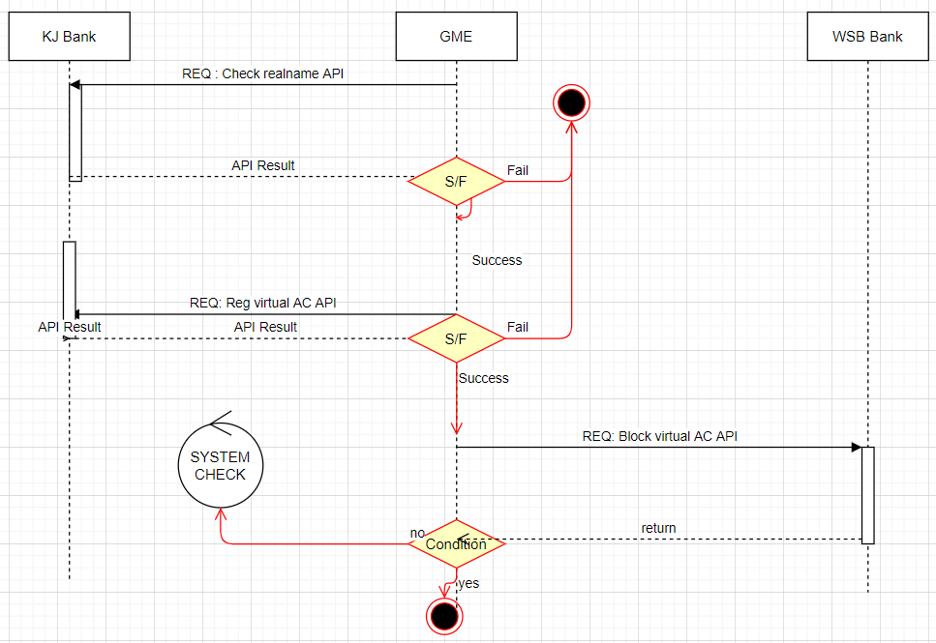

# 6. UI Design

## 6.1 Easy Remit Customer Block

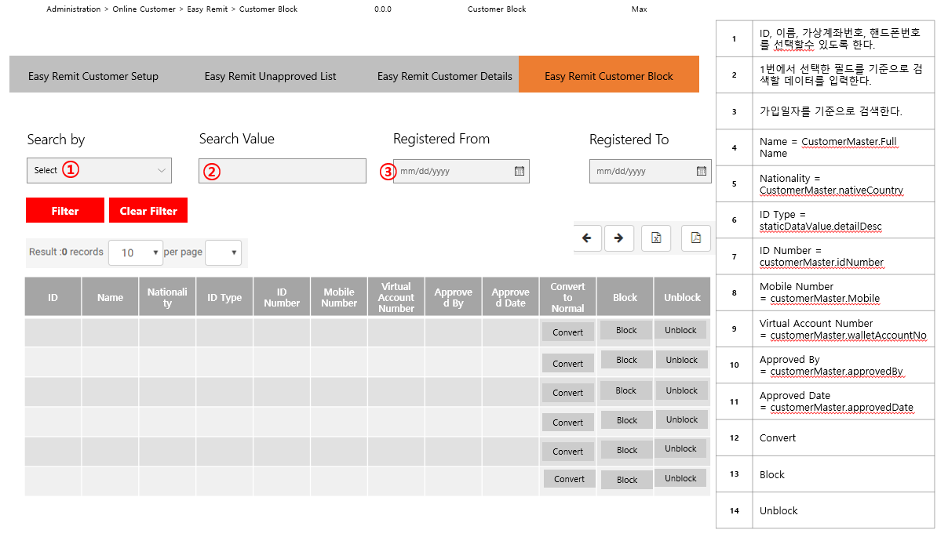

## 6.2 Convert to Normal

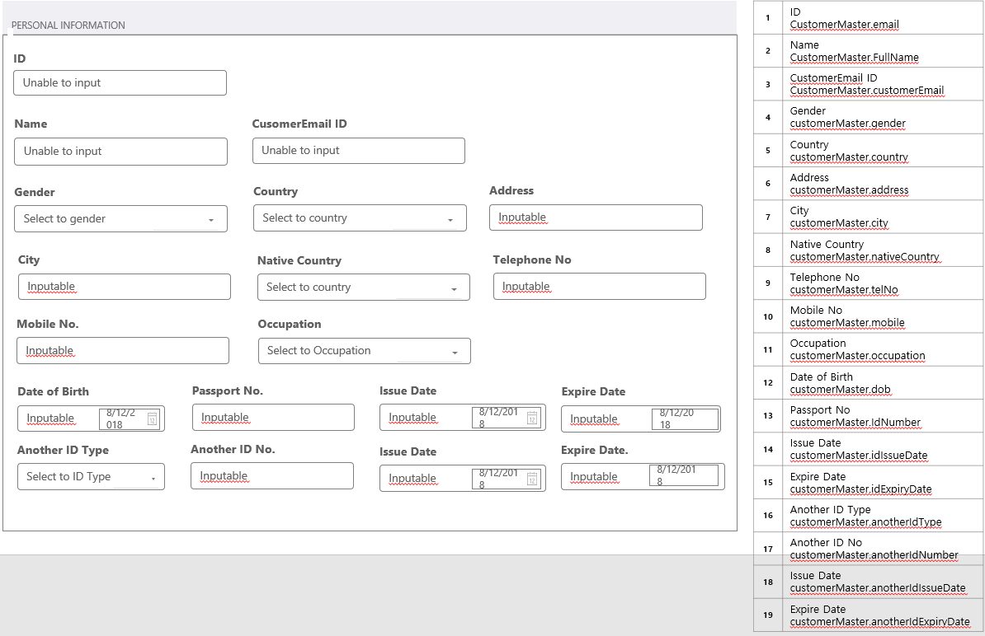

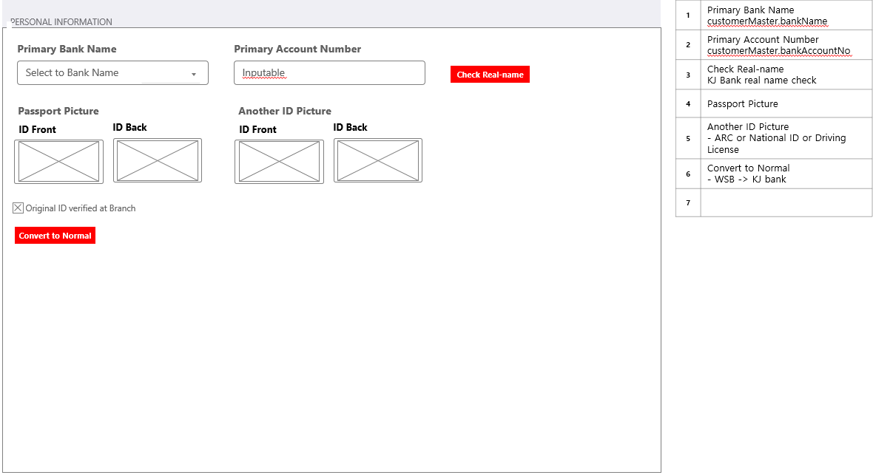

## 6.3 Message windows

